**© 2015 – Foxes Team**

<http://process.ws>

**Abstract**

This document describes in detail the requirement process  
which will use to define the Requirement Plan.

**Process for**

**Requirement Management Phase**

**Foxes Project**

**Table of Contents**

1. Introduction 2

1.1. Purpose 2

1.2. Intended Audiences 2

2. Process Objectives 2

3. Requirement Management Process 3

4. Process Roles and Responsibilities 3

5. Process Description 4

5.1. Requirement Elicitation and Analysis 4

5.2. Requirement Specification 6

Revision 6

**Table of Figures**

Table 1 - Intended Audiences 2

Figure 2 - Requirement Management Process 3

Table 3 – Roles and Responsibilities 4

# Introduction

## Purpose

The purpose of this document is to define the requirements processes and procedures to be used by the Foxes Team in Capstone Project.

## Intended Audiences

|  |  |
| --- | --- |
| Audience | Reference Purpose |
| Customer | Review and approve their requirements. |
| Mentor | Reviewing to help Foxes team improve the quality of Requirement phase. |
| Foxes Team Members | All document |

Table 1 - Intended Audiences

# Process Objectives

Process of Requirement Phase will:

* Steps to elicit & analyze the Requirement from customer, generate a new document named: Requirement Process.
* In order to develop and manage requirements from customer with consistency.
* The process will define how to elicitation and analyze the requirement, how to gathering the requirements and manage them effectively.

# Requirement Management Process

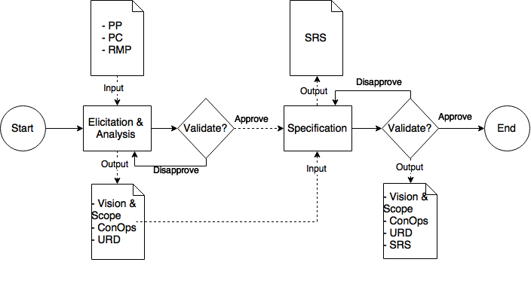

Figure 2 - Requirement Management Process

Document in this sub-process:

* PP: Project Plan
* PC: Project Charter
* RMP: Requirement Management Plan
* ConOps: Concept Of Operation
* URD: User Requirement Document
* SRS: Software Requirement Specification

# Process Roles and Responsibilities

|  |  |
| --- | --- |
| Roles | Responsibilities |
| Requirement Lead | * Develop a requirement plan and monitor, control team to follow it. * Ensure arrange adequate resource to collect and manage requirement. * Check and ensure quality of requirement documents from requirement engineer. * Contact directly with customer. * Validate requirement with customer. |
| Requirement Engineer | * Use techniques to gather and manage customer’s requirement. * Analyze the requirement. * Write documents for requirement. |
| Architect | * Consider whether requirement can be achieved or not in architecture aspect. * Focus on collect architectural drivers. |
| Stakeholder | Provide requirement and validate documents for Requirement Phase |

Table 3 – Roles and Responsibilities

# Process Description

## Requirement Elicitation and Analysis

|  |  |
| --- | --- |
| **Purpose** | By using methods to collect requirements to understand customers such as:   * Requirements, goals, objectives of customer * Vision and Scope of project * Constraint on software |
| **Required Input** | 1. Project Plan 2. Project Charter 3. Requirement Management Plan 4. Adequate resource for requirement phase: peoples, tools, training techniques, process for requirement development and management. |
| **Expected Output** | 1. Vision & Scope 2. Concept Of Operation 3. User Requirement Document (URD) |
| **Participants** | 1. Requirement Leader (RL) 2. Requirement Engineer (RE) |
| **Activities:**   1. First, we carry out elicitation from customer:  * Collect some basic data from customer by a survey that have question either multiple choices or short essays to customer. Then, Foxes Team will analyze, make a conclusion based on data get from customer. * In addition, team will make some questions for them to know about their working environment, current application, technical... * Conducting meeting with customer to listen and question to know more about current system (If yes). There are 2-3 members (Requirement Leader, Requirement Engineer, Architect and Supporter) will attend that meeting. We will meet them directly and work with them. Some techniques will use in this meeting: * Interview: one asks and the other notes. Team also prepare some scenarios, when customer raise some ideas, we will use those scenarios to explore more information. * Brainstorming: we will let customer brainstorming to raise their ideas, which not have in some interview scenario or questions. We will discuss with them about that and write down all to analyze later. * Prototyping to help customer know more interface of application and website.  1. Then, basing on elicitation we conduct analyzing by use some technical:  * 5 W + 1 H (Why, what, who, when, where and How) to analyze and define customer’s need and most of element (may be process flow, quality attribute, technical/Business constraint …) in project to priority requirement. * Interview to get solution from all members. * Questionnaire * Brainstorming  1. After that, conducting priority requirement based on trade-off among requirements to make decision, then develop solution for customer.   Finally, conducting verify that solution are correct and meet customer needs.(Elicitation and Analysis may be executed multiple times (loop) to get the most requirements correct)  4. We need to get approval of customer about all output of this step. If customer approve all document, we will execute next step. And If customer don’t approve, we will execute this step until got approval. | |

## Requirement Specification

|  |  |
| --- | --- |
| **Purpose** | Create and complete a document clearly and precisely records each of the requirements of the system or product |
| **Required Input** | 1. Vision & Scope 2. Concept Of Operation 3. User Requirement Document (URD) |
| **Expected Output** | 1. Software Requirement Specification (SRS) |
| **Participants** | 1. Requirement Leader (RL) 2. Requirement Engineer (RE) 3. Architect 4. Stakeholder |
| **Activities:**   1. After Requirement Analysis phase, requirement team will update or fix some document in previous phase. Those are Vision & Scope, Concept Of Operation, User Requirement Document. 2. When requirement team understand clearly this documents, then they will conduct developing software requirement specification document. 3. Foxes Team will held a meeting with customer to present all documents and get approval about it, this meeting will help all stakeholders consistent with one another. Besides, it help customer clearly about features, functions when project team develop software. | |

# Revision

|  |  |  |  |
| --- | --- | --- | --- |
| # | Date | Editor | Description |
| 5 | Sep 6th, 2015 | Tỷ Trần | * Updating with the new template. |
| 4 | Aug 17th, 2015 | Chi Tô | * Review and update Process. * Complete document. |
| 3 | Aug 16th, 2015 | Chi Tô | * Complete document. |
| 2 | Aug 13th, 2015 | Chi Tô | * Updating Purpose and add “Activities” in description table. |
| 1 | Aug 1st, 2015 | Chi Tô | * Creating Document. * Defining Requirement Management Process. |